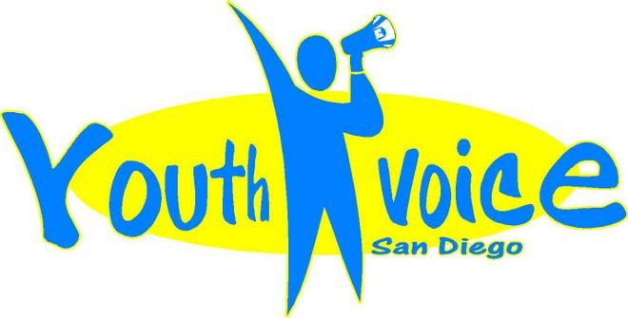
EARLY RESULTS: Youth Voice has presented in the last year before the San Diego Police Department; Commission on Gang Prevention & Intervention; San Diego Workforce Partnership; County Probation Department; Public Defender; Early Childhood Mental Health Conference; international visitors from the European Union, Middle East and North Africa; and California Department of Public Health.

PARTNERS: Juvenile Services Team of the Mid-City Police Division, Health & Human Services Agency, National Conflict Resolution Center, San Diego State University, Point Loma Nazarene University, and San Diego Advocacy Council.

FACTS: City Heights is the most diverse community in San Diego. It’s also where three out of four parents are worried about gangs in their neighborhood and at school, and where nearly half of residents say they feel unsafe in their community. Only 63 percent of the adults in Mid City have a high school diploma, and 33 percent are not fluent in English.*

Data Source: As cited on kidsdata.org Rodriguez, D., et al. (2016)
“When I was a little girl, no one told me that daddy hitting mommy wasn't okay…No one told me that I'm capable of greatness and with no one to care, that depression is all I can bear. Having someone touch you against your will has brought silence and pain that can never heal. As a woman today, the scars still remain. With the pain of no one listening, being so young I had to discover how to live as my only supporter.” —Betty Brezil
YOUTH VOICE
- Develops a train-the-trainer model, wherein Youth Voice leaders train peers locally, regionally, nationally and globally.
- Serve as experts on trauma in their community, have suggestions for solutions, and have made a great impact as leaders and advocates for trauma-informed systems across sectors (e.g. education, foster care, probation).
- Forms collaborative partnerships with community agencies that serve as a model for innovative solutions to support resilience and leadership.

COMMUNITY STORIES
YOUTH VOICE SAN DIEGO

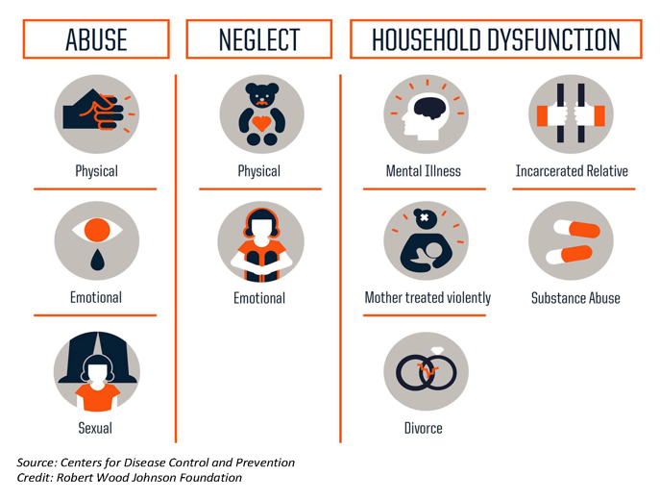
WHY ACEs MATTER: Adverse childhood experiences, or ACEs, are potentially traumatic experiences that occur in childhood, such as abuse, neglect, substance abuse or mental abuse in the household, domestic violence, or having a parent in prison. In the absence of a nurturing caregiver or other protective factors, these early adverse experiences can negatively impact growing brains and bodies.

The more types of trauma people experience, the more severe the consequences. Compared to someone who did not experience any childhood adversity, for example, a person who has experienced four ACEs is 12 times more likely to attempt suicide, seven times more likely to become an alcoholic, and twice as likely to have heart disease or cancer. People with high ACE scores are more likely to struggle with depression and autoimmune diseases. ACEs can also affect a child’s health and wellbeing during their childhood. More broadly, ACEs have a negative impact on our schools, criminal justice system, economic vitality, and public health.
WHAT YOUTH VOICE SAN DIEGO IS DOING ABOUT ACEs:
- Impacting policy and systems change.
- Educating leaders globally on trauma-informed resilience building.
- Transforming lives of youth through understanding and by presenting the science of ACEs.

JOIN US: Contact Dana Brown, Executive Director, at (858) 472-2321.www.youthvoicesandiego.com
Learn more about the California Campaign to Counter Childhood Adversity at 4CAKids.org.

