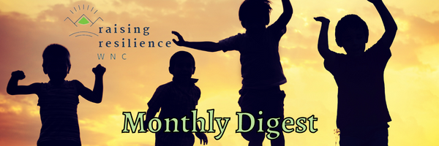

Dear Early Childhood Education Leaders and Learners, Happy September!

You are receiving this communication because you are a part of the Raising Resilience WNC Communication Network. We continue to reach out to those who ask questions and request to be invited to our regional network as we learn and grow.
Raising Resilience WNC is a collaborative group of the Western region Smart Start partners. We aim to strengthen resilience skills throughout individual and organizational levels of early childcare communities. We are doing this by listening to community members and partners to arrive at collaborative and iterative strategies for resilience. The strategies we currently are using include Sesame Street in Communities, Resources for Resilience Reconnect Training, and the Center for Trauma Resilient Communities Resilience Academies. With this community-based approach, we have the potential to create a regional system capable of supporting positive early childhood experiences and relationships.
Raising Resilience WNC Announcements & Bright Spots

Recent Year One (September 2021-August 2022) Bright Spots!

We would like to raise up and celebrate the following teams and communities for hosting successful Sesame Street in Communities (SSIC) launch events.

Let’s Raise Up and Celebrate!
Region A Partnership for Children, Swain County and our Swain Super Sesame Street Kick Off
Saturday, August 13th Riverfront Park, Bryson City
Executive Director, Janice Edgerton, jedgerton@rapc.org

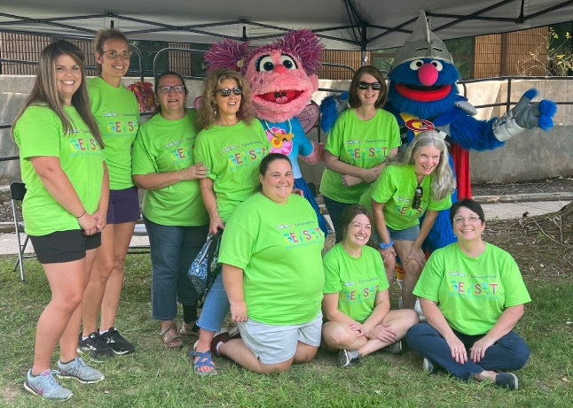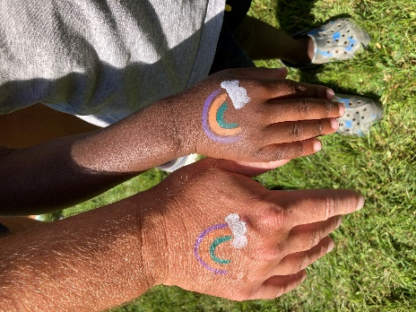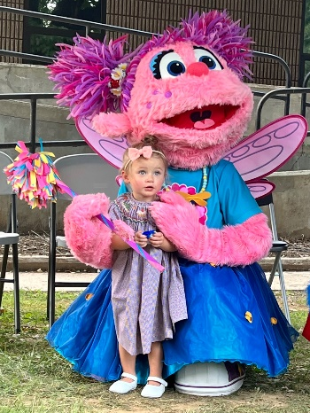
Get Set/Region A Event Organizing Team Members Face & Hand Painting for the Whole Family SSIC Abby Cadabby & Friend

Impact Statement, Region A Local Partnership for Children, Swain County, Staff Member Voice

We asked local Smart Start partnership staff to describe powerful interactions they saw between children, caregivers, and community partners they felt will leave a lasting impression on the children and families who attended. This is what Wendy felt moved to share:

“Working in the tent at the main entrance, I had the opportunity to welcome guests as they arrived, as well as thank them as they were leaving, and every single family that came through there offered thanks and praise for the event. Children and parents alike said how much fun it was, and many parents specifically said the event was something the community needed. It provided many positive childhood experiences in this community.”

Moreover, she described how the event made a lasting impact on her as she describes the working organizational resilience of her team:

“Since beginning my job at the partnership six months ago, I have always understood how important the work is regardless of the role played in the organization; however, it was at this event I was able to see just how much our work impacted the Swain community. Sitting behind desks every day, the fruits of our labor are most often seen at a distance through statistical data and occasional images, but seeing it unfold in person is an experience I will never forget. And it was not just certain roles that impacted the community that day, it was everyone coming together to work for the community that made such a difference.”

~Wendy Buchanan, Communications Outreach Coordinator, Region A Partnership for Children, Swain County, (in photo above, bottom row, middle staff)

Smart Start Partnership for Children, Henderson County, and our Smart Start Sesame Street Party
Saturday, August 20th Main Street Hendersonville
Executive Director, Sonia Gironda, Sonia@smartstartpfc.org

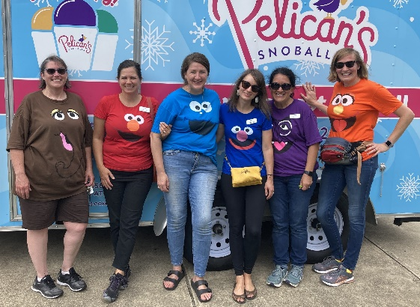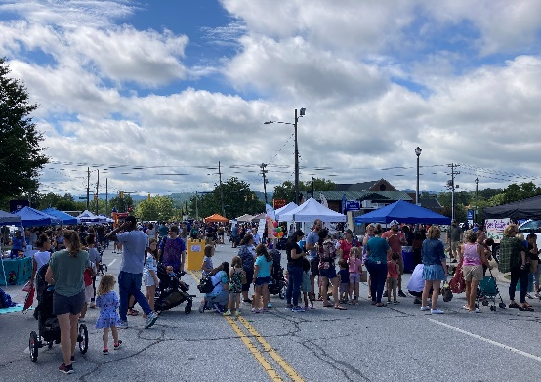
Smart Start Partnership for Children Event Organizing Team Main Street Hendersonville- Event Site Face Painting-Love

Impact Statement, Smart Start Partnership for Children, Henderson County, Staff Member Voices

We asked local Smart Start partnership staff to describe how they noticed the social emotional resources that were shared, were perceived by the attendees. This is what Kelly felt moved to share:

“While hosting the Resilience ‘Bounce Back’ activity at the Smart Start table, I invited children to choose a ball out of my bucket to bounce. I would then tell the parents that we were demonstrating our ability to bounce back after tough times. Many, many parents and caregivers responded with, “I love that!” One mother, who had 5 children with her, said, “we know about tough times! We’re staying at a local domestic violence shelter for women and children, and we could really use some bouncing back right now.” Kelly Hart, Program Director, Smart Start Partnership for Children, Henderson County (in left photo above, far right staff member)

Likewise, Ashley described the comfort levels families were feeling with the concept of resilience by the end of the event day:
“Almost every adult who came to our tent was receptive to the idea of resilience building and bouncing back. There wasn’t any suspicion. I’m not sure I’ve felt that level of trust at other events. I was a bounce back machine!” Ashley Lamb, Program Coordinator, Smart Start Partnership for Children, Henderson County (in left photo above, third from right, staff member)

Please see the one-minute Sesame Street in Communities “Bounce Back” YouTube Video resource shared at the Henderson County partnership table, located on SSIC Topics page. It is catchy- promise!

SSIC launch events highlight the importance of social-emotional learning and highlight the free resources that SSIC has to offer that support resilience building. Each Smart Start local partnership and their associated community partners have a slightly different approach to hosting SSIC events, because each of our communities are uniquely special. These events offer resources to early childhood education providers, parents and community members while simultaneously providing positive childhood and family experiences for all who attend. SSIC launches serve as the seed for building deeper community relationships surrounding these topics, awareness building around these educational tools, community partnership building for future events, as well as offer positive childhood experiences.

Looking Ahead in Year Two (September 2022-August 2023)

Resilience Trainings
We offer resilience trainings with the purpose of connecting anyone who works in a childcare center to resources that can support their wellbeing and providing knowledge and tools to transform the policies, practices and structures that erode resilience in our organizations and agencies. We are in the process of planning three Resilience Academies throughout September 2022 and February of 2023 with Smart Start local partnerships in Partnership with the Center for Trauma Resilient Communities. In the subsequent months of March 2023 through August 2023, our Partnerships will identify goals and opportunities for strengthening organizational strategies, policies, and practices.

Similarly, we are in the process of continuing to support individual early childhood education resilience building. We are in the process of planning three Reconnect for Resilience trainings throughout September 2022 and February of 2023 in partnership with Resources for Resilience.

Upcoming Events or Trainings

Foothills Partnership for Children, A Day of Fun-Get Set with Sesame Street, Saturday, September 24th at the Pavilion on Park Square, 153 Park Square, Forest City
Executive Director, Barry Gold, barry@pfcfoothills.org

Reminders

Please continue to visit and share Our Raising Resilience WNC calendar of events to stay up to date on the events and trainings being offered within the next quarter, as they pertain to each local community. Stay tuned for events hosted in your local communities!

As a learning offering, we invite you to read the Stanford Social Innovation Review article, “The Relational Work of Systems Change”. Its powerful and shifting the way we think about how we are doing our work!

If you do not wish to receive further communication from me as the leader of this regional work, please ask me to be removed from this email. This communication will be sent once a month, or less, as relevant information arises.

Please let me know if you have any curiosities, questions, or feedback for our team. On behalf of our entire Raising Resilience WNC team, thank you for our continued learning journey.

Onward!

Adrienne Gilbert-Stevenson, Regional Program Manager, Raising Resilience WNC
adrienne@smartstartpfc.org | Raising Resilience WNC Website

If you have resources or events to share with the Raising Resilience WNC Communication Network, please send information to adrienne@smartstartpfc.org.

